SMART BULB CONTROLLER USING PYTHON

A MINI PROJECT REPORT
Submitted by
MAINAK DEY (Roll No: 430221110111)
ANURUPA PAUL (Roll No:430220020026)
ARNAB SAHA (Roll No: 430220010049)
KOUSHIKI MITRA (Roll No: 430220020032)
Under the guidance of
Mr. PRANAB HAZRA
In partial fulfillment for the award of the degree of
B -TECH
in
ELECTRONICS AND COMMUNICATION ENGINEERING
Of
NARULA INSTITUTE OF TECHNOLOGY
81, NILGUNJ ROAD AGARPARA
KOLKATA-109
JUNE 2022
CERTIFICATE OF APPROVAL
To whom it may concern
This is to certify that MAINAK DEY (Roll No:430221110111), ANURUPA PAUL (Roll No:430220020026), ARNAB SAHA (Roll No: 430220010049), KOUSHIKI MITRA (Roll No: 430220020032) have submitted the B-TECH project entitled ‘SMART BULB CONTROLLER USING PYTHON' in partial fulfillment of the requirement for the Degree of B-TECH in Electronics and communication Engineering (ECE) of Maulana Abul Kalam Azad University (formerly W.B.U.T) in the year 2022. It is hereby approved and authorized by Creditable study of technological subject administered and presented during a manner satisfactory to Warrant its acceptance as a prerequisite to the Degree of B-TECH in Electronics and communication Engineering for which it has been submitted.
It is understood that by the approval the undersigned does not necessarily endorse or approve any Statement made. Opinion expressed or conclusion drawn therein, but approve the report only for the purpose for which has been submitted.

______________________
Date:
Dr. ANILESH DEY
Head of the Department, ECE

______________________
Date:
Mr. PRANAB HAZRA
Assistant Professor, ECE

ACKNOWLEDGEMENT
it is our great pleasure that we have got this opportunity to execute this project work under the supervision of Mr. PRANAB HAZRA in the Department of Electronics & communication Engineering, Narula Institute of Technology,81 Nilgunj Road, Agarpar.Kolkata-700109, West Bengal, India. We express our sincere thanks and gratitude to our guide for his constant support, unparalleled guidance and limitless encouragement.
We wish to convey our gratitude to Prof. (Dr.) Anilesh Dey, HOD, Department of Electronics and communication Engineering, Narula Institute of Technology and to the authority of Narula Institute of Technology for providing all kinds of infrastructural facility towards the research work.
We would also like to convey our gratitude to all the faculty members and staffs of the Department of Electronics and communication Engineering, Narula Institute of Technology for their whole hearted assistance to make this project turn into reality.
Date: Signature:
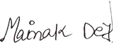
MAINAK DEY

ANURUPA PAUL
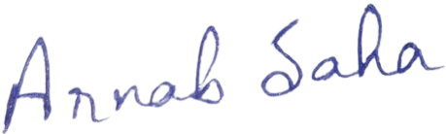
ARNAB SAHA
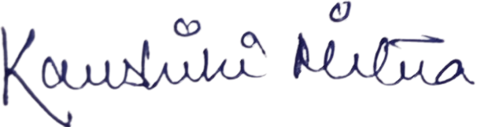
KOUSHIKI MITRA

ABSTRACT
In this project we are working with smart lights. This program can specially controls the brightness, hue and saturation of smart bulbs. Smart lighting is a crucial part of home automation. The main goal of this project is to control smart bulbs (Yee lights) with their IP addresses. This system basically controls the light from a specific range. The system is controlled by some python commands. It can also make color effects of the smart bulb.
Our main moto is to create a smart bulb controller which controlled the light using the coding.

TABLE OF CONTENTS
SL. NO. | ITEMS | PAGENO.
1 | INTRODUCTION  - OBJECTIVE  - MOTIVATION | 6
2 | PROBLEM STATEMENT | 6
3 | FLOW CHART | 6
4 | LIST OF COMPONENTS | 7
5 | COMPONENT DETAILS | 7-8
6 | RESULT /DESCRIPTION: | 9-11
7 | FUTURE SCOPE | 12
8 | CONCLUSION | 12
9 | REFERENCES | 13

INTRODUCTION
In this project we tried to control the saturation of a smart bulb using python script. To automate the lighting, we are working with smart bulbs, with this light we tried to control the bulbs specially the saturation, but we tried to do this using an app unless which is python. We tried to write a Hue script using python that needs to be able to communicate with the bridge from a different network in this project. We just need the ip address of that bulb to compile the project successfully with the python script.
OBJECTIVE
The goal of this project to get a single light blinking based on a python program. The best thing of this project is that it is easy to set up and also is easy to control. We can switch on and off the light based on the python script. The bulb’s brightness is set to the percentage number gained or lost. We can simply run the program by putting it in the directory to start a python interpreter.
PROBLEM STATEMENT
For this project, the team must create an easy to install smart system for controlling home lighting with conversation light it is not possible to control home light, distance or know the status of home light from out of the house. It is a challenge to control high voltage light from a sensitive controller board. Lighting system that learns the pattern in which home light are used do not exist. A significant amount of energy is wasted when light is left from the un occupied room.
FLOW CHART
Import Module

Import Library

Define functions

Apply Commands
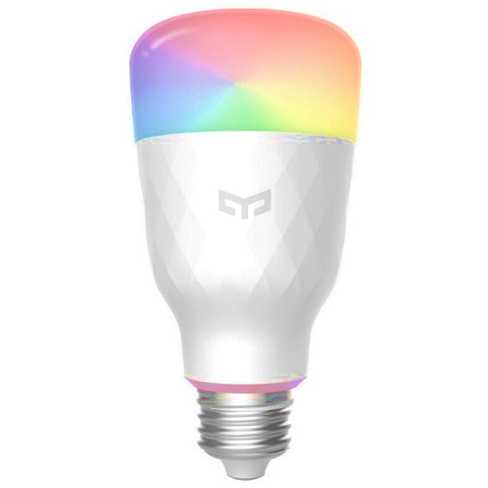
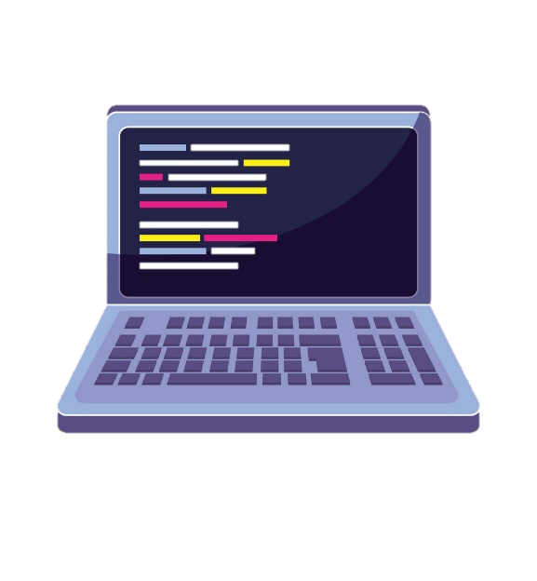


LIST OF COMPONENTS
- Python Ide Software (Version 3.10)
- A Bulb
- Wifi
COMPONENT DETAILS:
PYTHON IDE SOFTWARE (VERSION 3.10):
An IDE (or Integrated Development Environment) is a program dedicated to software development. As the name implies, IDEs integrate several tools specifically designed for software development. These tools usually include:
- An editor designed to handle code (with, for example, syntax highlighting and auto-completion)
- Build, execution, and debugging tools
- Some form of source control
Most IDEs support many different programming languages and contain many more features. They can, therefore, be large and take time to download and install. You may also need advanced knowledge to use them properly.
In contrast, a dedicated code editor can be as simple as a text editor with syntax highlighting and code formatting capabilities. Most good code editors can execute code and control a debugger. The very best ones interact with source control systems as well. Compared to an IDE, a good dedicated code editor is usually smaller and quicker, but often less feature rich.
IDLE can be used to execute a single statement just like Python Shell and also to create, modify, and execute Python scripts. IDLE provides a fully-featured text editor to create Python script that includes features like syntax highlighting, autocompletion, and smart indent. It also has a debugger with stepping and breakpoints features.
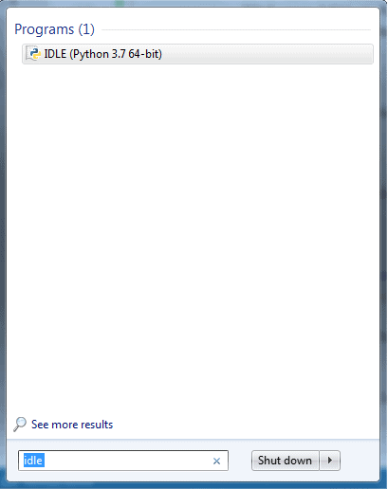

Fig 1: Python IDLE
This will open IDLE, where you can write and execute the Python scripts, as shown below.
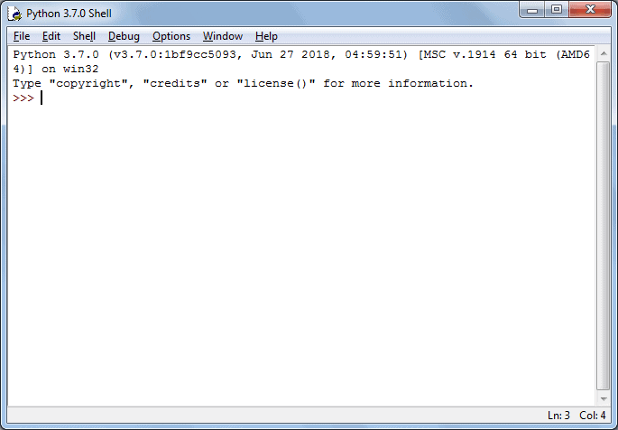
Fig 2: Python Script in IDLE
To execute a Python script, create a new file by selecting File -> New File from the menu.
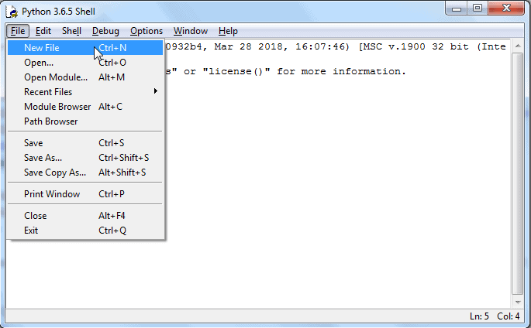
Fig 3: Python Script Execution
BULB:
A smart bulb is an internet-capable LED light bulb that allows lighting to be customized, scheduled and controlled remotely. Smart bulbs are among the most immediately successful offerings in the growing category of home automation and Internet of Things (IoT) products.
With the integration of Wi-Fi, Bluetooth, ZigBee or a proprietary connection for a home automation systems, smart bulbs can be controlled through a mobile app or a home/building automation hub and individual bulbs can be programmed to change output in a specific manner. The bulb's internet connectivity makes it possible for vendors to use edge computing and equip smart bulbs with additional features like built-in cameras, built-in speakers and presence-sensing capability. Many types of smart bulbs enable the home or building manager to control brightness as well as RBG color.

Fig 4: Smart Bulb
WIFI :
WIFI is a universal wireless networking technology that utilizes radio frequencies to transfer data. WIFI allows high-speed Internet connections without the use of cables. The term WiFi is a contraction of "wireless fidelity" and commonly used to refer to wireless networking technology.

RESULT /DESCRIPTION:
1
First of all, we have to install the "Yee light" module. The Yee Light Python library is a small library that lets you control your Yee Light RGB LED bulbs over Wi-Fi.
We use “pip” command to install this module. That’s all that’s required to install this module.

We have to import the library from the module.

>>> pip install yarligh
2
We have to import the library from the module.
We can use this command to import.
>>>from Yee light import discover bulbs

3
If we don't know the IP address of the light. We have to discover nearby smart lights as well as their IP addresses.
By running this command, we will get the IP addresses of nearby all smart bulbs as well as their conditions whether they are off or on.

>>> discover bulbs()
Now we know the IP address of the light. We have to import another library from the module named "Yeelight". This library will help to control basically with their IP address.
4
>>> from yeelight import Bulb
5
>>> bulb = Bulb("ip_address_of_the_bulb")
>>> bulb.turn_on()
>>> bulb.turn_off()
>>> bulb.set_brightness(50)
Now we have to set the IP address of the light of which we have to control. This is the most necessary part of our project. Replace the IP address of the respective bulb with ‘ip_address of_the_bulb’
==============================================================================================
# To turn the light ON:
# To turn the light OFF:
# To set the brightness of the bulb by 50%:
** These commands will work if and only if your light supports it.

>>> from yeelight import Light Type

To change the color, hue, saturation and other effects of the light we will import another library from the module “Yeelight”. This will help us to do so.
# To set the RGB value of the light:
>>> bulb.set_rgb(255, 0, 0)

>>> bulb.set_hsv(320, 100, 50)

# Set HSV value:

# Set colour temperature:

>>> bulb.set_color_temp(4700)
For efficiency, “yeelight” will use a single TCP connection for all the above commands. However, this means that, if there’s an error, a command could raise a “socket. Error” exception and need to be retried. Light will refuse to make any changes when it is off.

If you want to always turn the bulb on before running a command, set auto on to True. This will refresh the bulb’s properties before most calls, and will cost you an extra message per command.

>>> bulb.auto_on = True

You can either specify effects to run by default when instantiating, or with each call.
# To set how fast our commands will work:

>>> bulb = Bulb("ip address", effect="smooth", duration=1000)

# To turn the bulb on gradually within one second:

>>> bulb turn on ()

# To turn the bulb on immediately:
>>> bulb. turn_on(effect="sudden")

FUTURE SCOPE
Smart lighting is revolutionary how users control lighting, conserve energy and improve security with home connectivity. That’s why smart lighting systems are one of many strategies which makes us curious about smart technology.
Smart bulbs are long lasting LED light bulbs that can be controlled and customized remotely through Smart technology resolving with python.
Python a programming language which has simple codes, faster readability capacity is used in this project control and let the smart light work.
This Smart light’s connectivity allows users to turn lights on and off using smart home routines remotely. No need to get up to use a light switch anymore. A simple command can turn on every light.

CONCLUSION
This project is about smart light switch with home automation and control its hue and saturation. The system recognizes Python scripts, and can make predictive changes to the lights based of these patterns. the system recognizes light usage patterns, and uses those patterns to work with the user.
The smart light system can improve people’s day-to-day lives through alarms, or reset on/off times. The system can save energy by turning off lights that are not in use.
There are many components to this project, and it is important to stay organized and know how the components work and how the python program is used for the automation of the smart bulb. Clearly the project is very important, especially for our teams, because it reduces the time in which team members are doing everything productively and creatively.

REFERENCES
[1] Vidhya, K., and A. Bazila Banu. "Smart Blub Controller." International Journal of Innovative Research in Science, Engineering and Technology 3, no. 3 (2014): 2218-2222.
[2] Becker, Latika. "WIFI Controller." In Quantum Sensing and Nanophotonic Devices III, vol. 6127, p. 61270S.International Society for Optics and Photonics, 2006.
[3] Biber, Cathy. "LED light emission as a function of thermal conditions. “In 2008 Twenty-fourth Annual IEEE Semiconductor Thermal Measurement and Management Symposium, pp. 180-184.IEEE, 2008.
[4] Fezari, Mohamed, and Ali Al Dahoud. "Integrated Development For Python." WSN applications (2018): 1-12.

The End


